Study Skills
Timelines
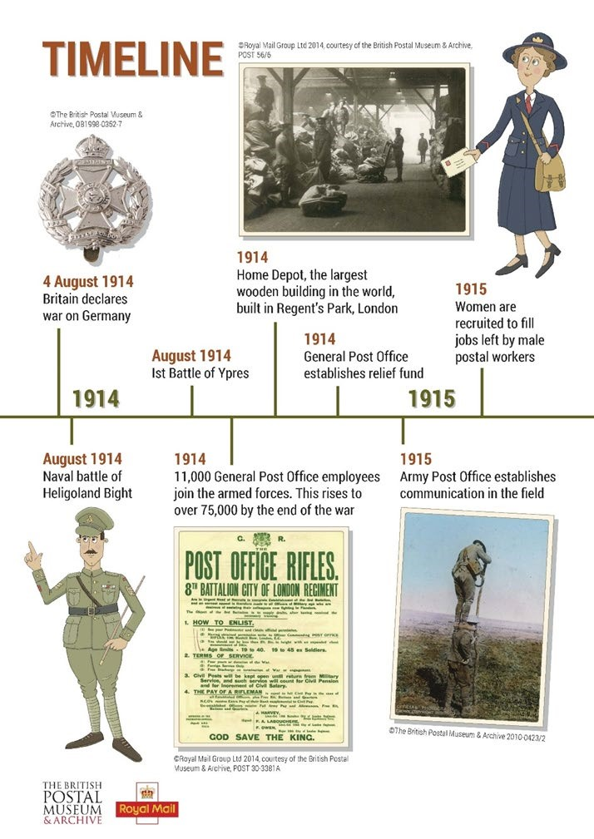
Timelines
Timelines are useful to help you remember the
chronological order of events.
This could be the key events of a particular time
period, or could be the
events found in a play or book.
Like a mind map it helps if you use colour to
categories, and use pictures to help you
remember certain facts.

