Study Skills
Repetition

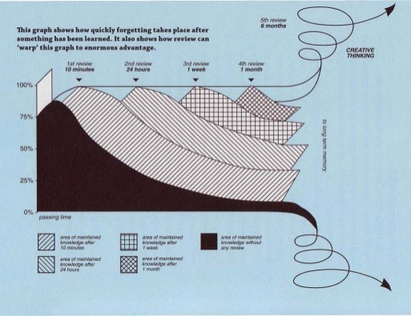

New information is stored in your short-term memory. To
Repetition
transfer it to your long term memory you need to repeat an action at least 5 times before the information is transferred to your long-term memory. Otherwise information is forgotten.
Review and repeat what you have learnt:
- Shortly after you have learnt it
- One day after you have learnt it
- One week after you have learnt it
- One month after you have learnt it
5. Three to six months after you have learnt it

