Study Skills
Pictures

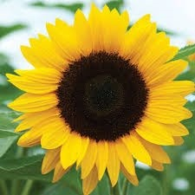

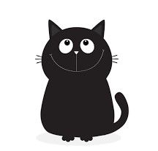

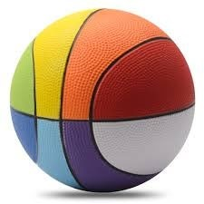

They say a picture paints a thousand words.
Pictures
The human brain finds it easier to remember images rather than words.
Look at the words and pictures on the right… if they disappear which do you remember more of?
Chair jacket dog bag spade book

