Study Skills
Mnemonics


Mnemonics (pronounced ‘nem-on-ic’
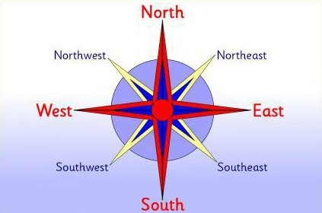
Mnemonics work by stimulating your imagination and by using words and to encourage your brain to make associations
Imagine you were asked to remember the points of a compass, you could use the first letters of the words you need to remember North, East, South West - and use alternative
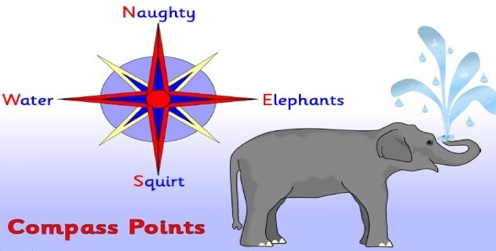
words to help you for example Naughty Elephants Squirt Water

