Study Skills
Mind Maps

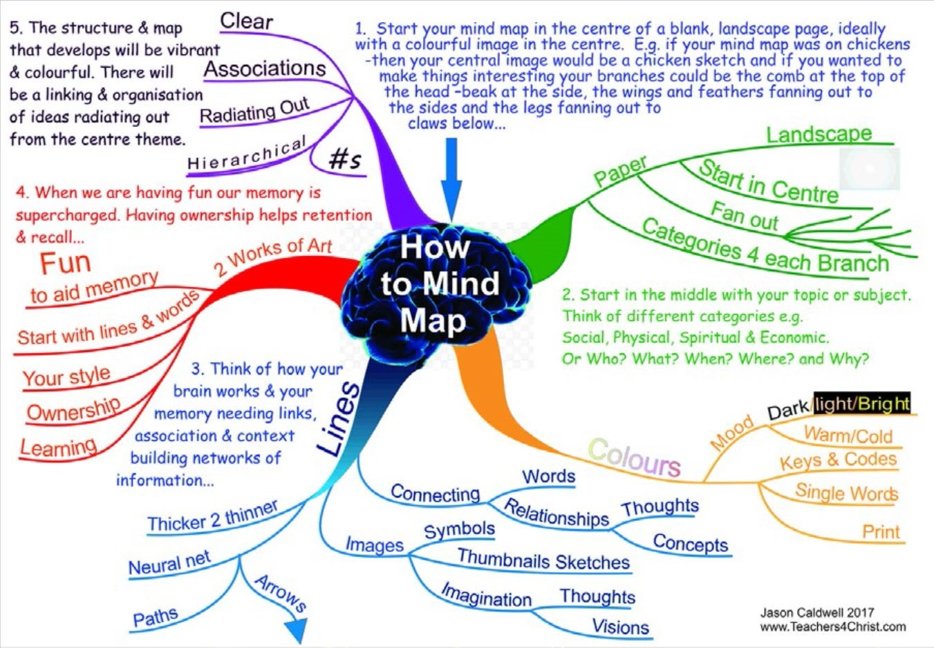
Mind Mapping is a
process that involves a
combination of text,
images, colour and
visual-spatial
arrangement.
Once you have made
your map, cover it and
test yourself on different
strands, e.g.
how much of the blue
strand can you recall?
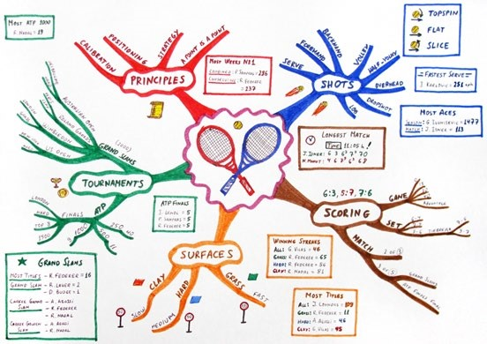
•
An example of a
mind map about
tennis

