Study Skills
Key words
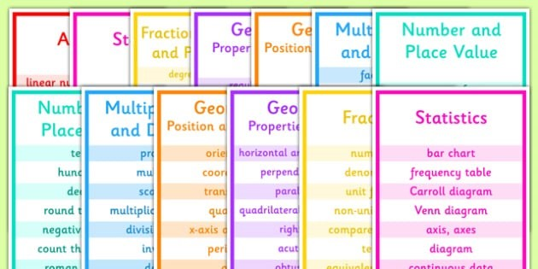

When we speak or write we use sentences with a beginning, middle and end but our memory doesn’t work in the same linear fashion.
Key words
Often a key word can ‘jog’ your memory to remember a range of other information about a topic without having to remember every single word from a text/lesson.
Try using key words in your learning to see if it helps you to remember whole topics without you having to waste time writing down unnecessary words.

