Study Skills

Connect Your Learning
We often think of the topics we learn in isolation. We need to start connecting this information if we are to remember it in the long term. Start by choosing three concepts/theories/ideas in your chosen subject. Create three different mindmaps for each topic. Once you’ve finished, try to connect each mind map so that it turns into one big mind map! How does each topic or theory link with another?
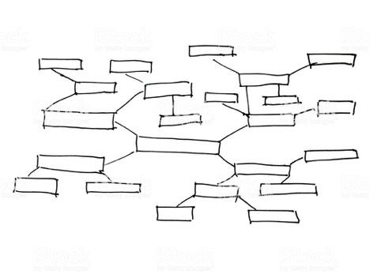
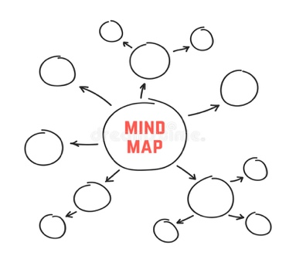
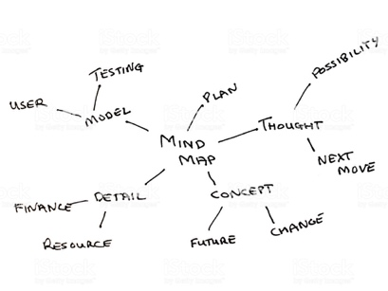
Topic 1
Topic 2
Topic 3
How do these topics link or connect to one another?
How do these topics link or connect to one another?
How do these topics link or connect to one another?
Example:

