Study Skills
Clock Learning


Clock Learning
- A revision clock is similar to a mind map as it breaks down the content in to manageable chunks.
- First you draw a basic clock.
- You then take a subject or a topic and break it down in to 12 sub-categories/facts/key points.
- Make notes in each chunk of the clock.
- You can then use the clock to revise – maybe spend 5 minutes on each segment.
- You can turn the clock over and try to remember/write out as much information as you can from one segment e.g. all of the information in the 3pm – 4pm segment.
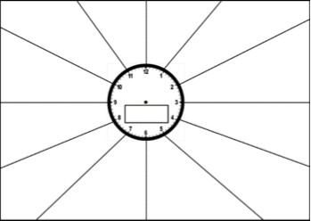 This method can be useful to help visualise a timeline of key dates or events.
Clock Learning
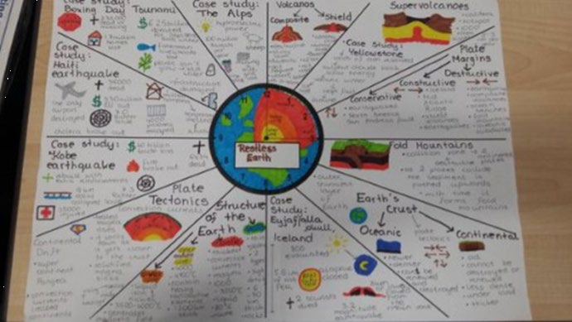
- An example of clock learning about earth

