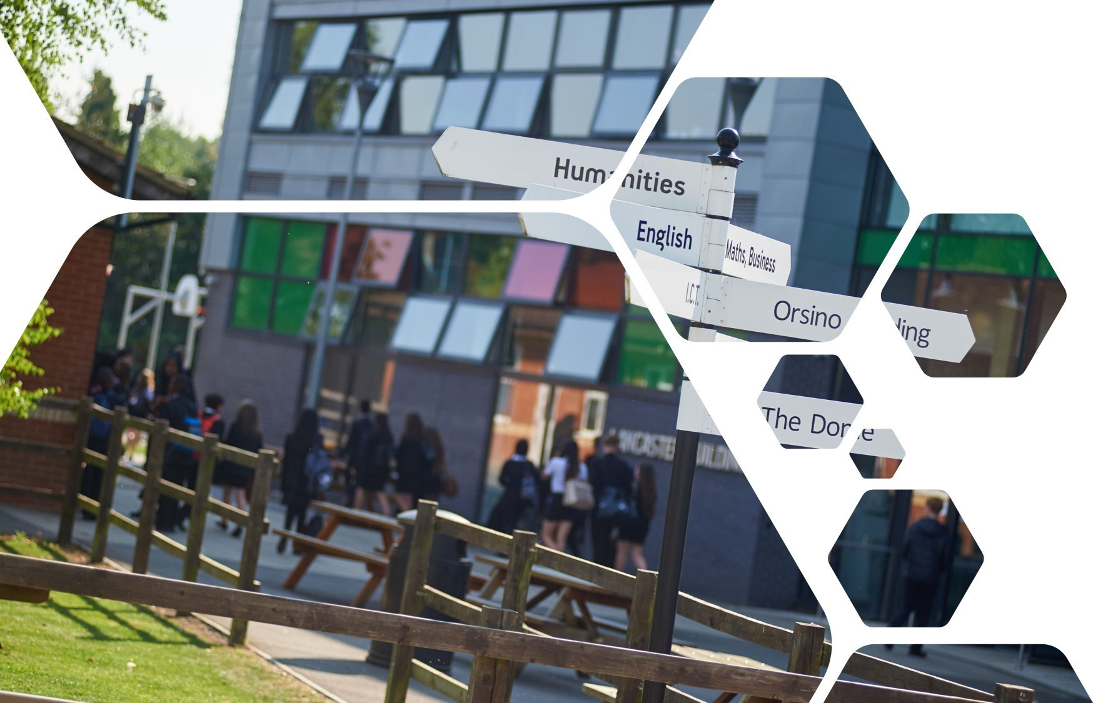

Year 6 - 7 Transition Pack

Year 6 to Year 7
2023

Introduction to transition work

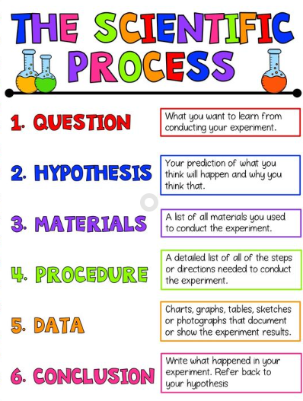
Welcome to Science at Uxbridge High School.

This booklet will give you some insight of the enquiry process you will be undertaking in your lessons on your journey through Science while you explore topics in Biology, Chemistry and Physics.

Being a scientist is great fun. Science is all about being curious, asking questions and investigating to find the answers.

We hope as you work through this booklet, you get a taster of all the amazing things that we explore in Science at Uxbridge High.

We look forward to welcoming you in September!

The Science Team @ UHS

The Scientific Method

A scientific method consists of six key steps.
Watch the video using the link, then write down the steps below. https://www.youtube.com/watch?v=yi0hwFDQTSQ

Now follow the instructions on the pages below and complete the tasks.

Scientific enquiry
Task 1 - Choose the best explanation to explain each statement. Some explanations match more than one statement.
The first one has been done for you.: Scientists repeat experiments because they need to make their results as accurate as possible.
You may use the space on the last page of this booklet to write your sentences.

statement | because | explanation
Scientists repeat measurements  In an enquiry scientists change one thing while keeping everything else the same  Scientists make sure they have enough readings Scientists draw graphs of their results  When collecting results scientists measure things carefully  Scientists often make a prediction Scientists use scientific ideas  Scientists often do a control experiment where  they keep everything the same | because | it makes it easier to spot patterns in their results  to help them decide what to investigate they want to be sure of their conclusions  they need to make sure the effect is not just something that would have happened anyway  they need to make their results as accurate as possible  they often have an idea of what will happen before they do the experiment  they want to make it a fair test  they want to make sure their results are reliable

Task 2 – Units and Measurements
Match the correct units to the measurements. The first one is done for you.

cm | The speed of a train
cm2 Length of an earthworm
N/cm2 | The area of a shoe in contact  with the ground
cm3 | The pressure exerted by a force  over a specified area
A | The volume of copper sulfate solution  at the start of an experiment
J | The current in an electric circuit
N | The amount of energy transferred  in an activity
°C | The force acting on something
pH | The temperature of a beaker  of water
km/hour | The acidity or alkalinity of  a solution

Task 3: Experiment

Des carries out a simple experiment to investigate how things warm up.

Des did an investigation on the bench in his laboratory.
He put some ice in a plastic cup and the same amount of ice in another plastic cup.
Cup 1 was not insulated.
Cup 2 had a thick cloth around it.
Des measured the temperature every minute, collected his results and plotted a graph.
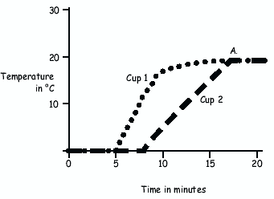
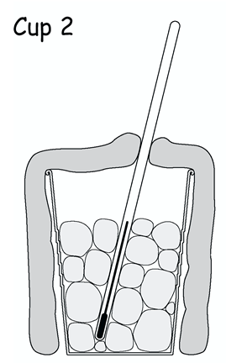
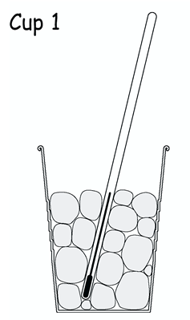

Match up the correct statements to answer the questions in the left- hand column.

Why did the lines for both cups join and become horizontal at ‘A’? | The same size, type and thickness of cup, put the cups in a similar position on the bench, stirring the contents of both cups
What was happening in both cups in the first 5 minutes? | The water in the cups had reached room temperature
Des correctly said that the temperature of the water in cup 2 started to rise quickly after about ……… | The ice was melting
Des said that the graph shows that his prediction was correct.  What do you think his prediction was? | 8 minutes
What does Des have to do to make sure his prediction was correct? | That the ice would take longer to melt in the insulated cup
Des says that he did a fair test by putting the same amount of ice in each cup. What else would he have to do to make the test fair? | He must repeat the experiment

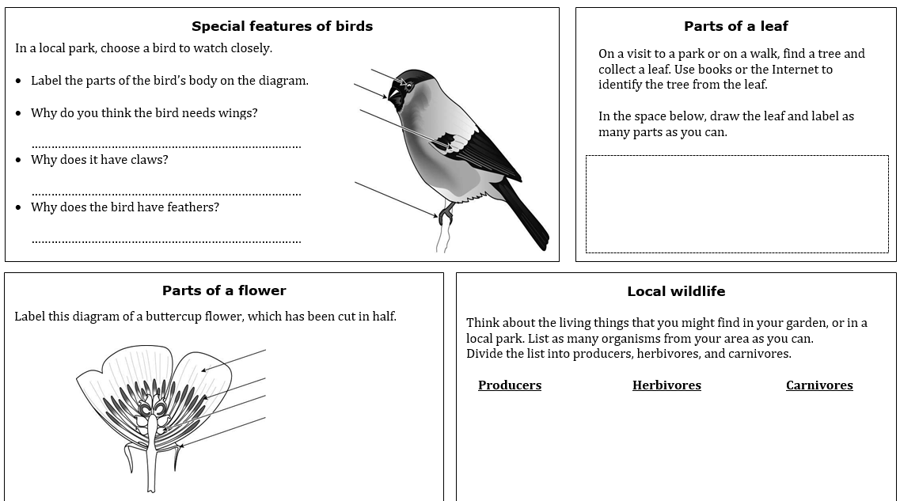
Task 4: Biology

Task 5: Chemistry
Why is my birthday important in chemistry?
My birthday is on: ____________________________
The name of my chemist is: ___________________________________
My chemist is from this country: _______________________________
This is what my chemist did: __________________________________
_________________________________________________________
_________________________________________________________
Here is a picture of my chemist, or something my chemist discovered.
Birthday chemistry
Every day, scientists do investigations and make observations to answer questions in chemistry. These scientists are called chemists. Chemists work out why materials have certain properties. They find out how materials change in chemical reactions. They create new materials, with perfect properties for purposes.

What to do

- Go to this website: http://www.rsc.org/learn- chemistry/collections/chemistry-calendar
- Click on your birthday.
- Fill in the form to show others in your new class why your birthday is important in chemistry.

Hints
- Fill in the form in your own words.
- If there is a word you don’t understand, ask someone for help, or look it up in a dictionary or on the Internet.
- You can draw a picture or find one on the Internet, print it out, and stick it on the form.

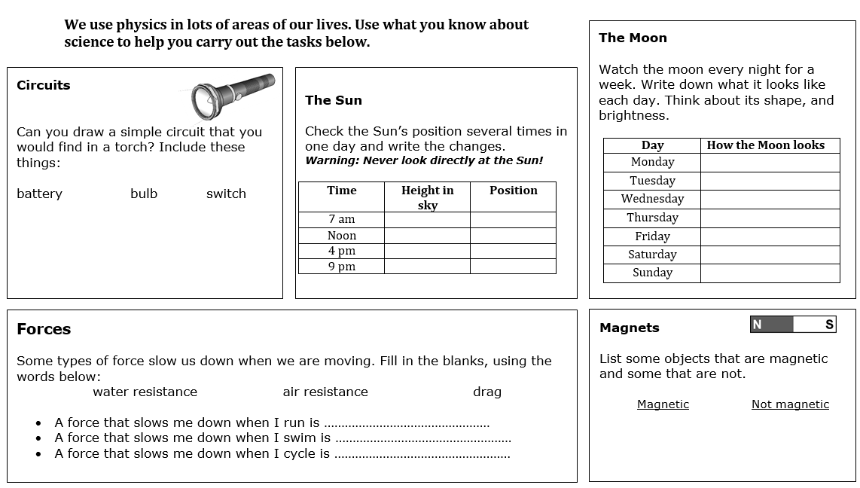

Task 6: Physics

