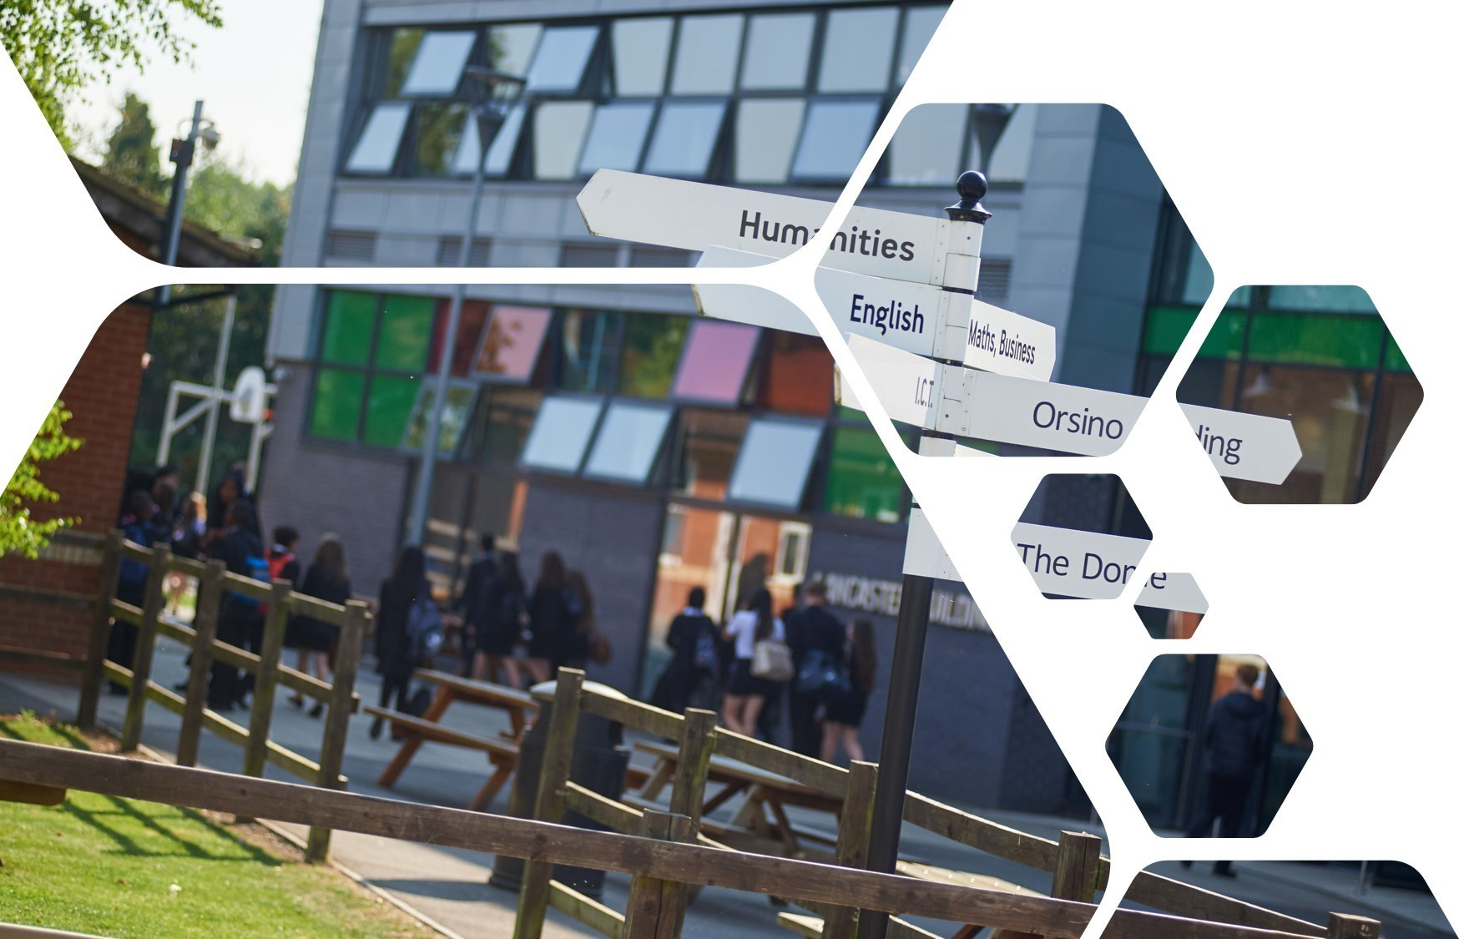
Year 6 - 7 Transition
MUSIC

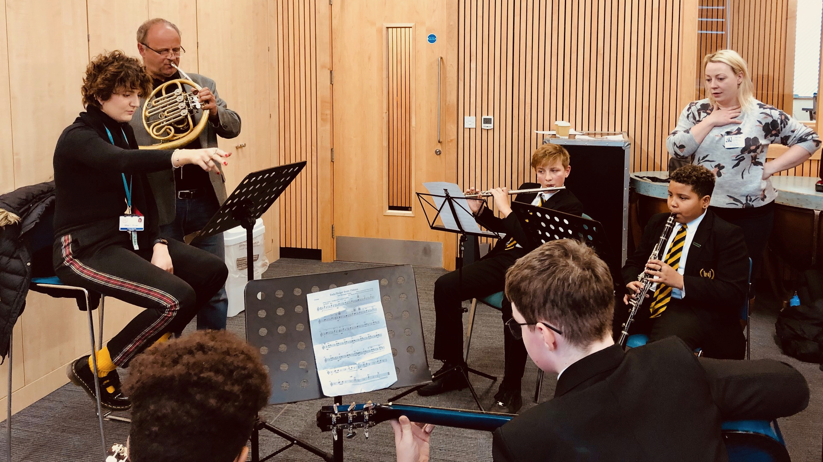

Why is MUSIC interesting and important?

Music is fun and helps you to get better at working with others.
Music builds up your confidence, increases your ability to listen and gives a big boost to your presenting skills. Music also teaches you to manage your time better, and to be able to perform tasks impressively, even when you’re under pressure.
As a subject, Music is highly valued by future employers and can lead into some of the most exciting and personally rewarding careers, like: Marketing, Management, Advertising, Film Producer, Mobile Phone Industry, Game Designer, Motorsport technical team, Sound Engineer, Event management, Blogger/Youtuber, Singer, Songwriter, Journalist, Audio system Design, Producer, Accounting, Radio and TV Industry, Music Therapy.
What topics will I study?
Music in Advertising, Film Music, Popular Music, World Music Cultures and World issues in Music are some of the fun topics that help you learn about the technical, emotional, social and cultural value of Music in all our lives.

What makes the curriculum exciting? Projects, activities and events?
Step into the Orsino building for Music and you’ll find yourself in a buzz of activity. There’s always a welcoming atmosphere and lots of students love our lunchtime and after school music clubs, like DJ club, Music Practice Club, Singing clubs and Instrument Groups.

We organise trips to great places like the Royal Albert Hall to hear world-class music performances.

Our students take part in special programmes for learning music instruments, with the support of our friends in the Hillingdon Music Hub. You can learn keyboard, guitar, drums, singing, violin, clarinet, trumpet, flute and many more with us! We also run the exciting Modulo instrument learning programme for enthusiastic students too.

Our regular concerts and showcases are always of high quality and feature some of the best performances by young people from any school in Hillingdon.

Several of our students have taken part in regional competitions for music and we even get visits by internationally known artists, such as Mobo Award winning Guvna B.
Summer Homework Task(s) for MUSIC
Choose one of the tasks below to complete before your first music lesson in September. You can do more than one task, if you wish:

Task 1. Design a musical instrument using household materials, preferably with GOLD colours somewhere in the design, so you can ‘Go For Gold in Music!’ you can design any instrument you like, but make sure it can make a good sound!
Helpful link: https://feltmagnet.com/crafts/Music-Instruments-for-Kids-to-Make

Task 2. Choose a song you like, preferably with the world ‘GOLD’ in it somewhere in the lyrics. Learn to sing it without the words in front of you. Practice weekly to make sure it is performance ready so you can perform the song in your first music lesson! Keep a log of your practices, describing what goes well and what needs still to be improved.

Challenge: Create some Dance Moves for your performance.

All songs chosen should be appropriate and in line with our PROUD values

