**Pit stop 2**: Complete the activities below

How would you feel once you finally got to your destination and got your gold?

**List five abstract nouns that you might feel:** *Excitement*

**List five verbs that you might when you get to your destination and get your gold:** *Smile*

**Write down one thing you compare your emotions to:** *Fireworks*

**What might you see when you arrive at your destination?** Mountains

**What might you smell when you arrive at your destination?** Meadows of flowers

**What might you hear at your destination?** Birds chirping

**What might you feel at your destination?** The wind tickling your face.

**What might you taste at your destination?** The excitement in the air

**Golden vocabulary**

Aglow, buoyant, cheerful, gleeful, jovial, jubilant, lively, merry, uplifted, fulfilled, elated, ecstatic, exuberant, euphoric, excited, exhilarated, exultant, marvellous

**Pit stop 1**: Match the techniques and examples to the definition

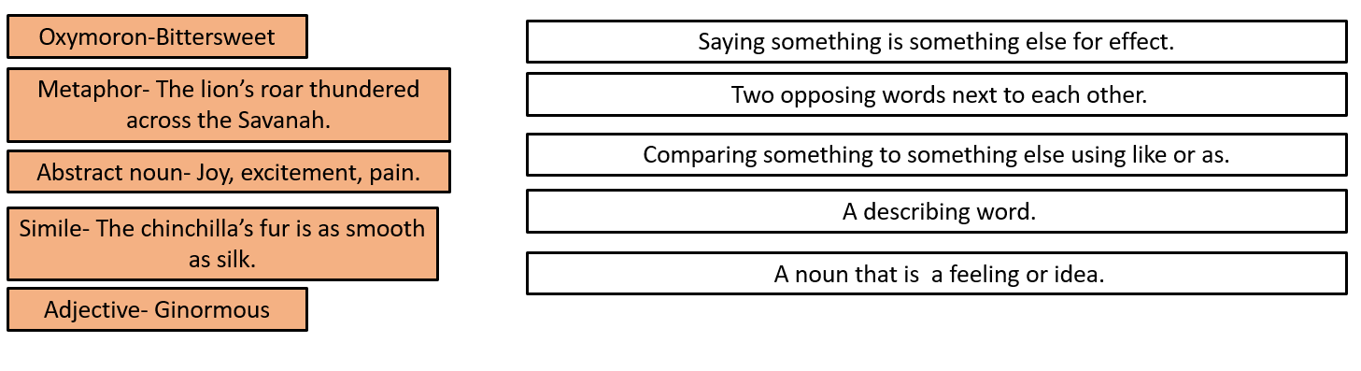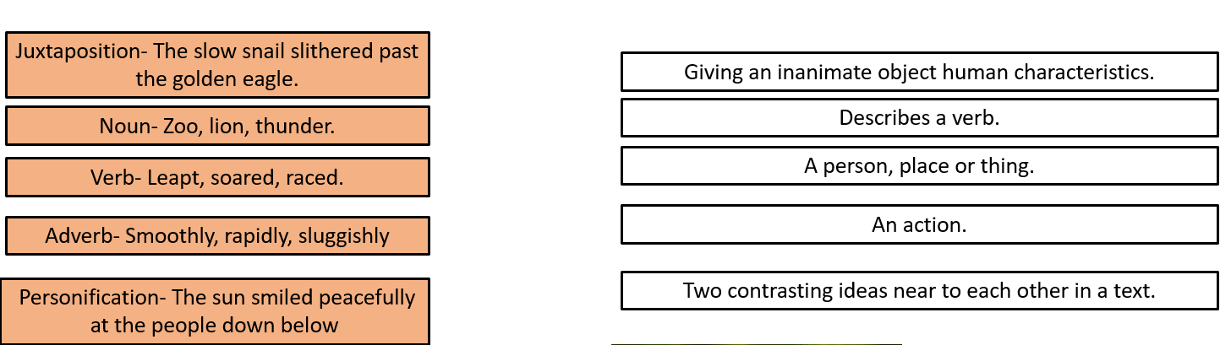

Tenzig Norgay was one of the first people to climb up Mount Everest.

Mansa Musa- Musa was the King of Mali in the 13th Century, one of the wealthiest people in the world at the time as well as one of the first explorers to discover America

Bessie Coleman- Coleman was the first black woman to receive her international flight license in 1920.

Ernest Shackleton- Shackleton was an Antarctic explorer

**The summit:** Imagine you are an amazing explorer who has just had a difficult and exhausting expedition.

You can:

-Describe the moment when you finally reach your destination.

**OR**

- Describe your surroundings when you get there.

**It must be at least two paragraphs long**

**You must use:**

-At least five language techniques.

- At least five examples of golden vocabulary.

- Five different sentence openers.

- Five types of punctuation

- Three different types of sentences.

**Example:**

*My reflection in the puddle on the ground gleamed, as I took in the beauty surrounding me. Majestic hills leaned into one another, forming a piercing emerald carpet that could be seen far into the distance. Their peaks, although sparking and once looming giants, were unable to block the buoyant beams from the sun. Each ray reverberated onto my face, radiating the joy I was feeling within. Bliss. I finally made it. Grateful, I stopped to bask in the splendour all around me. With each breath, I released my anxiety and breathed in accomplishment. I will remember this moment forever.*

Matthew Henson- Henson was the first person to reach the North Pole in 1909.

Here at Uxbridge High school, we view going for gold as trying our very best to be excellent.

In your first term at Uxbridge High School, we will be learning about explorers and expeditions.

Here are some explorers who have gone for gold.

Amelia Earhart- Earhart was the first female aviator to fly solo across the Atlantic Ocean.

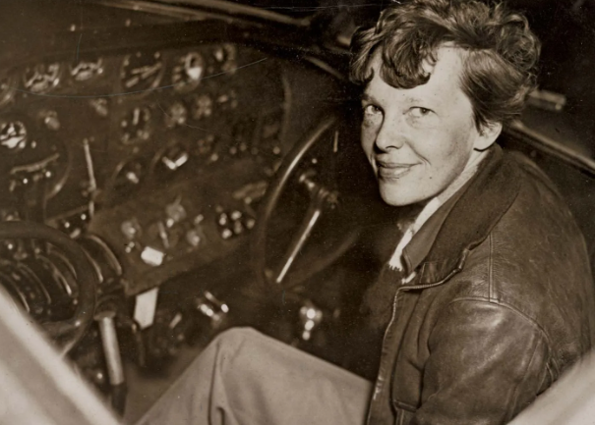

**Going for Gold**



